**Smart Shopper**

final Report

Mustafa Noori

Graduation

Fontys University of Applied Sciences

Jan 07 2024  
Student number: 3014630

Venlo, Limburg

|  |
| --- |
| Date: 07/01/2024 |
| Version: 0.1 |
| State: |
| Author: Mustafa Noori |
| Total Words: 9921 |
| Words Intro-Conclusion: 7858 |

**Version history**

|  |  |  |  |  |
| --- | --- | --- | --- | --- |
| **Version** | **Date** | **Author(s)** | **Changes** | **State** |
| 0.1 | 07/01/2024 | Mustafa Noori | Initial draft |  |

Distribution

|  |  |  |
| --- | --- | --- |
| **Version** | **Date** | **Receivers** |
| 0.1 | 07/01/2024 | Sander Bruinsma |
|  |  | Jelle Baede |
|  |  | Denis Gorianin |

**Table of Contents**

1 Introduction 1

1.1 Company: CGI 1

1.2 Context 1

1.3 Background 1

1.4 Research Question 2

1.5 Report Structure 2

2 Project Overview 3

2.1 Project Objective 3

2.2 Project Deliverables 3

2.3 Approach & Phasing 4

2.3.1 Approach 4

2.3.2 Phasing 4

2.4 Scope 5

2.5 Out of Scope 5

2.6 Project Management 6

2.6.1 Team Structure 8

2.6.2 Risk Management 8

2.6.3 Change Management 9

3 Analysis 10

3.1 Expectations of the Customer 10

3.2 Acceptance Criteria 10

3.3 Market Analysis 11

3.4 Technology Stack Analysis 11

3.5 Functional Requirements 11

3.5.1 Use Case Diagram 11

3.5.2 Use Case Description 12

3.6 Activity Diagrams 14

3.7 Sequence Diagrams 14

3.8 Data Requirements 15

3.8.1 Data Dictionary 15

3.8.2 Data Constraints 15

Research 17

3.9 Introduction 17

3.10 Literature Review 17

3.11 APIs 17

3.11.1 Checkjebon API 17

3.11.2 Shopping Scraper API 18

3.11.3 Superscanner API 18

3.11.4 Websrapping.Amsterdam API 18

3.12 APIs Pro’s and Con’s 19

API 19

Advantages 19

Disadvantages 19

3.13 Methodology 20

3.14 API Result 21

3.15 Conclusion 22

4 Design 23

4.1 Functional Design 23

4.1.1 Wireframe Design 23

4.1.2 Navigation Diagram 24

4.2 Visual Design 25

4.2.1 Moodboard 25

4.3 Technical Design 26

4.3.1 ER Diagram 26

4.3.2 Relational Model 27

4.3.3 Database Schema 28

5 Implementation 29

5.1 Architecture 29

5.2 Stack 30

5.2.1 Mobile Frontend: 30

Backend Development: 30

5.2.2 Database: 32

5.2.3 Version Control: 32

6 Advice 33

6.1 Continuous Improvement 33

6.2 Data Security and Privacy Compliance 33

6.3 Scalability Planning and Integration Opportunities 33

6.4 Agile Project Management 33

7 Conclusion 34

8 Reference 35

9 Appendix 38

**Table of Table**

Table 1: Project Deliverables 4

Table 2: Scope 5

Table 3: Out of Scope 6

Table 4: Risk Management 9

Table 5: Acceptance Criteria 11

Table 6: Search Item 13

Table 7: Get Direction 14

Table 8: User Data Dictionary 15

Table 9: Data Constraints 16

Table 12: User Database Schema 28

Table 13: Grocery Data Dictionary 38

Table 14: Supermarket Data Dictionary 39

Table 15: Location Data Dictionary 39

Table 16: Product Image Data Dictionary 39

Table 17: Products Database Schema 39

Table 18: Stores Database Schema 39

Table 19: List Database Schema 39

**Table of Figures**

Figure 1: Sprints 6

Figure 2: GitHub Project Board 7

Figure 3: Project Management Team Structure 8

Figure 4: Use Case Diagram 12

Figure 5: Search Item Activity Diagram 14

Figure 6: User Registration Sequence Diagram 15

Figure 7: APIs Result 21

Figure 8: Search Wireframe 24

Figure 9: Navigation Diagram 25

Figure 10: Moodboard 26

Figure 11: ER Diagram 27

Figure 12: Relational Model 28

Figure 13: Architecture Comparison 29

Figure 14: Backend Development 31

Figure 15: Database 32

Figure 16: Home Wireframe 41

Figure 17: Register Wireframe 42

Figure 18: List Wireframe 43

Figure 19: All Lists Wireframe 44

Figure 20: Create New List Wireframe 45

Figure 21: Supermarket Based Dropdown List 46

Figure 22: Same Supermarket Total 47

Figure 23: Stores Routing 48

**Acronyms**

API Application Programming Interface.

IP Internet Protocol.

IT Information Technology.  
JSON JavaScript Object Notation.

UI User Interface.

PSC Project Steering Committee.

ER Entity Relationship.

OSRM Open Source Routing Machine.

**STATEMENT OF AUTHENTICITY**

Issued by the FHTenL Examination Board, September 2017

I, the undersigned, hereby certify that I have compiled and written this document and the underlying work / pieces of work without assistance from anyone except the specifically assigned academic supervisor. This work is solely my own, and I am solely responsible for the content, organization, and making of this document and the underlying work / pieces of work.

I hereby acknowledge that I have read the instructions for preparation and submission of documents/pieces of work provided by my course / my academic institution, and I understand that this document and the underlying pieces of work will not be accepted for evaluation or for the award of academic credits if it is determined that they have not been prepared in compliance with those instructions and this statement of authenticity.

I further certify that I did not commit plagiarism, did neither take over nor paraphrase (digital or printed, translated or original) material (e.g., ideas, data, pieces of text, figures, diagrams, tables, recordings, videos, code, ...) produced by others without correct and complete citation and correct and complete reference of the source(s). I understand that this document and the underlying work / pieces of work will not be accepted for evaluation or for the award of academic credits if it is determined that they embody plagiarism.

Name (in capital letters): MSUTAFA NOORI

Student number: 3014630

Place / Date: Venlo, 10-10-2023

Signature: MN

**Abstract**

This final report for the Smart Shopper application redefines the shopping experience, seamlessly integrating technology and user-centric design to enhance efficiency and user satisfaction. Equipped with intelligent product search capabilities, the app allows users to quickly locate items, while its deal identification feature ensures optimal savings. The ability to create and manage shopping lists streamlines the preparation process, and location-based information about nearby supermarkets adds an extra layer of convenience. Built on a robust technological framework, including React Native, various APIs, and machine learning algorithms, Smart Shopper has successfully addressed challenges in technology integration, user experience refinement, and data synchronization.

# Introduction

## Company: CGI

CGI is a global IT and business consulting services company founded in 1976. With about 90,000 professionals across 400 locations1, they provide comprehensive, scalable consulting services across 21 industries. In CGI Eindhoven, where I'll be working, teams of 200 professionals focus on innovative technology solutions to address practical challenges in various sectors[1]*.*

The company's comprehensive services include consulting, systems integration, application development, and managed services. CGI's collaborative and client-centric approach has earned it a reputation for delivering high-quality solutions personalized to meet the unique challenges of its clients. This section introduces CGI as a key player in the IT industry, laying the foundation for a comprehensive exploration of its innovative Smart Shopper application1.

## Context

There have been significant changes to purchasing groceries recently. Ease has arrived at customers' doorsteps thanks to the growth of technology. But at the same time, several problems have been faced despite this ease and gro. To accomplish their shopping, consumers are now looking for more efficient and economical methods.

The growth of technologies has not only transformed the retail sector but has also redefined expats expectations. Against this scene, the Smart Shopper application arises as a cutting-edge solution aimed at improving the shopping experience. Developed by CGI, this innovative application addresses the challenges faced by contemporary shoppers, such as information overload, time constraints, and the desire for personalized and cost-effective shopping. By integrating advanced technologies like artificial intelligence, geolocation, and data analytics, Smart Shopper aims to allow users to make informed decisions, find the best deals, and optimize their shopping journeys. This section examines into the contextual framework that demanded the creation of Smart Shopper, setting the stage for a detailed exploration of its features and functionalities.

## Background

The Smart Shopper project has been considered to address the complex challenges of expatriates’ grocery shopping experience. Today's expatriates face several issues while shopping for groceries, such as unpredictable price variations, limited product information, complex decision-making, time-consuming processes, and missed opportunities for savings.

Recognizing these challenges, CGI has undertaken the Smart Shopper project to simplify expats' grocery shopping experience. The project's primary goal is to provide expatriates with a user-friendly mobile application that enables them to create grocery lists, receive real-time price information, discover current offers, and optimize their shopping across various supermarkets.

The Smart Shopper application happens as a transformative solution in the state of shopping applications, aiming to streamline and enhance the overall shopping experience for users. In response to the common challenges faced by shoppers, such as inefficient product searches, lack of real-time deals, and difficulty in managing shopping lists, Smart Shopper addresses these pain points with innovative features and robust technology. The primary goals and objectives of the project include the smooth integration of technology to facilitate intelligent and efficient product searches, identification of the best deals, and the creation and management of shopping lists. The overarching aim is to provide users with a user-centric and technologically advanced platform that simplifies the entire shopping process and ensures optimal satisfaction.

## Research Question

**Main research question:**

How can the Smart Shopper application enhance and optimize the grocery shopping experience for expatriates, considering factors such as efficiency, cost-effectiveness, and user satisfaction?

**Sub-questions:**

* What APIs are available that provide data on different products at several grocery stores in the Netherlands?
* What are the specific challenges faced by expatriates in their grocery shopping experiences?
* What features and functionalities should be prioritized in the Smart Shopper application to ensure a seamless and user-friendly experience for expatriates?

## Report Structure

The report has in total seven chapters in the following order: introduction, project overview, analysis, research, design, implementation, advice and followed by the conclusion. The chapters have been ordered in a way and understand the project’s activities in a logical order and are easy to understand.

# Project Overview

The Smart Shopper assignment aims to transform the grocery shopping experience by developing a mobile application. To simplify and enhance the shopping process, this project is started in the perception of the growing needs and preferences of modern expats. The application is designed to serve as a shopping guidance, presenting state-of-the-art technologies to provide expats with information, personalized recommendations, and the ability to locate the best deals in their area. In this section, we explore into the key objectives, scope, and deliverables of the Smart Shopper project. From its start to the expected results, this overview sets the stage for an in-depth exploration of the various aspects of the project.

## Project Objective

The main objective of the Smart Shopper project is to design and develop an intuitive mobile app that will allow expats to create, manage, and optimize their grocery lists efficiently. The application will have a store finder feature to find nearby supermarkets and view their details.

The Smart Shopper project is guided by SMART objectives, ensuring a focused and effective approach. The Specific aim is to create an intuitive mobile application delivering product information, prices, and personalized recommendations. Measurable success will be determined through user engagement metrics and the quantification of the recommendation system's impact. Achievability is grounded in the team's skills and the project's realistic scope. Relevance is maintained by addressing user needs and aligning with evolving consumer expectations. Time-bound objectives are set with a clear project timeline, milestones, and checkpoints for systematic progress tracking and adjustments.

## Project Deliverables

The project has been divided into the following milestones which represent the important aspects of this project.

|  |  |  |  |  |  |
| --- | --- | --- | --- | --- | --- |
| **Phase** | **Milestones** | **Major Deliverables** | **Progress** | **Start Date** | **End Date** |
| Project Preparation | M1: Project Initiation & Team Formation | - CGI mandatory training  - Define important tasks - Project Plan | Done | 01/09/23 | 30/09/23 |
|  |
|  |
| Analysis and  Research | M2: Requirements Analysis & APIs research | - Requirements gathering - Mid-term report - Research APIs - Mid-term presentation | Done | 01/10/23 | 14/10/23 |  |
|  |
|  |
| Design | M3: System Design | - Architecture Design - System Structure - UI Design - Provide Prototype | Done | 15/10/23 | 31/10/23 |  |
|  |
|  |
| Realization | M4: Infrastructure Setup & Data Integration | - Breakdown use cases - Prioritize use case - Realize each use case | Done | 01/11/23 | 30/11/23 |  |
|  |
|  |
| Final  Preparation | M5: Application Deployment & User Support | - Final report - Reflection report - Final Presentation | Done | 01/12/23 | 14/12/23 |  |
|  |
|  |
| End of  Project | M6: Project Evaluation & Closure | - Project Evaluation Report - Assessment  - Closure Activities |  | 15/12/23 | 06/02/24 |  |

Table 1: Project Deliverables

## Approach & Phasing

In planning the approach and phasing for the Smart Shopper project, a careful strategy was formulated. The initial phase involves a comprehensive analysis of user needs, market trends, and technological requirements. Following this, the design phase focuses on creating an intuitive and user-friendly interface, ensuring a seamless shopping experience. The following development phase involves the integration of cutting-edge technologies for data retrieval and recommendation algorithms. The final phase includes a thorough deployment plan to address any unforeseen issues promptly. This systematic approach and phased implementation ensure a well-organized and successful execution of the Smart Shopper project.

### Approach

The project will explore the availability of supermarket APIs and select the technology stack. Define user requirements, acceptance criteria, and deliverables. Create project architecture, user interface, and database structure. The approach adopted for the Smart Shopper project is customer-centric and technology-driven. It involves understanding user behavior, preferences, and pain points to modify the application for a personalized shopping experience. Leveraging data analytics and machine learning, the application refines its recommendations over time, ensuring relevance and accuracy. Additionally, a mobile-first strategy is embraced, recognizing the prevalence of mobile devices in users' shopping journeys. The iterative development approach allows for continuous improvements based on user feedback and evolving market trends. This approach not only meets the immediate needs of users but also positions Smart Shopper as an adaptive solution in the dynamic landscape of retail technology.

### Phasing

The project phases are setting up project infrastructure and team. Investigate supermarket APIs and select the technology stack. Define user requirements and project scope. The project is divided into strategic phases to ensure a systematic and efficient development process. In the initial phase, comprehensive market research and user studies are conducted to inform feature prioritization and design. The subsequent phase involves the development of a robust backend infrastructure capable of handling data analytics and user interactions. Simultaneously, the frontend is crafted for an intuitive and visually appealing user interface. The third phase focuses on implementing machine learning algorithms for personalized product recommendations and refining them through continuous learning. Testing and quality assurance are integrated throughout each phase to address issues promptly. The phased approach ensures a balanced progression, allowing for a timely delivery of valuable features while maintaining a strong foundation for future enhancements.

## Scope

The project's scope covers the development of the Smart Shopper application, a comprehensive mobile platform designed to improve the shopping experience through intelligent features. This includes the creation of user-friendly interfaces for smooth navigation, integration with external APIs for product information, and the implementation of advanced search algorithms to optimize item discovery. Additionally, the scope extends to the incorporation of location-based services for store recommendations and the integration of secure user authentication mechanisms. The application's scope also involves the implementation of a personalized list management system, enabling users to create, modify, and share shopping lists efficiently. The scope is planned to address the essential challenges of modern shopping, offering a full solution for expats to save their time, make informed decisions, and enjoy a more custom-made shopping experience. To explain the project's scope, including its various components and limitations. The scope of the Smart Shopper project covers the following areas in Table 2: Scope:

|  |  |
| --- | --- |
| **Scope areas** | **Explain scope** |
| **Business process / portfolio** | This includes improving consumers' grocery shopping experience and managing different data collection of products from supermarkets. |
| **Geographical** | Availability for expatriates in the Netherlands |
| **Organizational** | Collaboration with supermarkets and gathering pricing data and it integrates secure user authentication mechanisms to ensure data privacy and user-specific experiences. |
| **Application** | It outlines the features like advanced search algorithms, create a shopping list, look at products, and compare prices. |
| **Information** | It involves the management and presentation of product details, user preferences, and transaction history. |
| **Infrastructure** | This involves applying CGI's computer and network infrastructure to ensure efficient development and deployment of the mobile app. |

Table 2: Scope

## Out of Scope

While Smart Shopper ambitiously addresses a wide range of features, it's important to outline what falls outside its scope. To give a clear picture and prevent unrealistic expectations, it is important to specify what is outside of the scope:

|  |  |
| --- | --- |
| **Out of Scope areas** | **Explain out of scope** |
| **Local Stores** | Repositories for information that aren't available to the public. |
| **Store Operations** | The project is not in charge of overseeing the actual layout or running of the store. |
| **Payment** | Although the app offers price information, it does not permit in-app purchases. |
| **Delivery Services** | No service options are offered by the app. |
| **Expansion** | The app's geographic reach is restricted to a certain area, and it does not function abroad. |
| **Distribution** | The app will not be made available through open channels like app stores. |
| A multilingual app with many languages: (n > 2). | |

Table 3: Out of Scope

## Project Management

Project management is needed to ensure the effective planning, performance, and completion of all project tasks and objectives. In the developing process of the Smart Shopper application, an agile approach is used by conducting a daily stand-up and a two-week sprint as you can see in Figure 1. This will allow to break down the project into smaller chunks, which will be more manageable and easier to focus tasks which are called use cases.

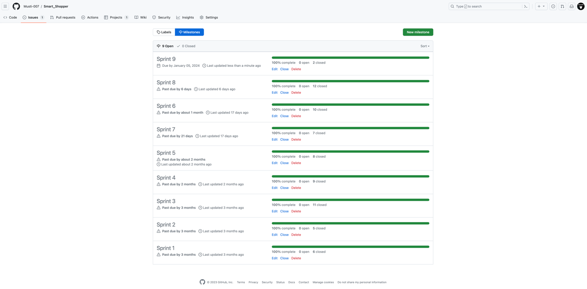

Figure 1: Sprints

Each sprint's initial tasks will be placed according to their complexity and impact on the project using GitHub labels as you can see below in Figure 2. This made it easier to focus on activities that involved using the must have, should have, and could have criteria of the MoSCoW principle. A sprint retrospective will be done at the conclusion of each sprint to assess results and identify potential areas for improvement. This includes analyzing what went well throughout the sprint and identifying any difficulties or problems that surfaced.

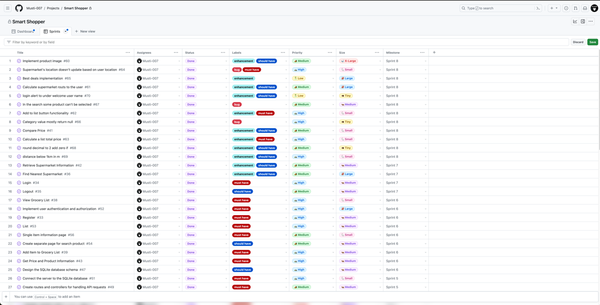

Figure 2: GitHub Project Board

At the end of each sprint, progress updates will also be sent to the project steering committee (PSC). In these updates, the tasks performed during the sprint will be briefed, problems or issues that emerge will be discussed, and an update on general progress will be provided, highlighting significant milestones, and pending obstacles or deadlines. Therefore, the key points below will be considered:

* A detailed project plan and a clear and well-defined project scope are developed.
* Recognizing and mitigating risks during the project's timeline will be done.
* Quality assurance will be integrated into each phase of the project.
* Effective communication within the team and with stakeholders is established.
* A change management process will be in place to handle any changes to project scope, objectives, or requirements.
* A closure phase at the end will ensure that all project objectives have been accomplished.

### Team Structure

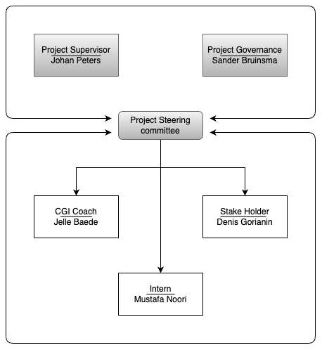

Figure 3: Project Management Team Structure

### Risk Management

The following **Error! Reference source not found.** outlines the risks recognized so far regarding the project, with proposed countermeasures, the chance of occurrence, and the extent of the (negative) impact on the project (on a scale from 1 to 5) [2]. The last column indicates the calculated risk (chance * impact). This way a well-founded weighing is possible of which risk deserves the most attention or resources.

During the project this list is continuously maintained in a Risk Log, with a more extensive description of the risks.

| Short description of risk | Short description of countermeasures | Chance | Impact | Calculated Risk |
| --- | --- | --- | --- | --- |
| Delays in API Access | Maintain open communication with supermarket APIs. | 30% | 3 | 90% |
| Insufficient Language Support | Implement a multilingual feature for the application. | 20% | 2 | 40% |
| Technical Challenges | Regularly review the project and adapt as necessary. | 20% | 5 | 20% |
| Not receiving feedback in time | Early planning and preparation in-time. | 30% | 3 | 90% |
| Lack of Supermarket Data | Research alternative methods for data collection. | 20% | 3 | 60% |
| Developer gets sick | Inform the team and rest to recover as soon as possible. | 20% | 5 | 100% |

Table 4: Risk Management

### Change Management

Change management procedures will be meticulously followed in the Smart Shopper project to guarantee that any changes to the project's scope are appropriately assessed and authorized. The PSC will be asked for approval of any proposed adjustments to the project's scope. A thorough risk and impact analysis will be given to the PSC for decision-making for changes that are anticipated to have a major impact on the project budget or timetable.

Small changes with minimal risk and impact, which can be managed within the tolerances of the current project phase, will be communicated to the PSC for information. The PSC will have a reasonable reaction time to review these changes. If the PSC does not recall the change within the stipulated time, the change will be executed.

A complete assessment will be done to make sure that all related papers, such as design, documentation, and test documents, are updated appropriately after any modification to the project requirements to preserve alignment with the new project scope. Within the confines of the project, these change management guidelines shall be followed to enable effective and controlled adjustments as needed.

# Analysis

In the analysis phase, gathering and documenting what the app needs to do has been done properly, both in terms of basic functions and other important stuff. It was carefully figured out how expats will use the app in different situations. Detailed charts and tables were made to help imagine the big picture.

To start with, a complete analysis of possible customers' requirements was conducted. This included close collaboration and communication with customers to identify their specific requirements and understand their expectations and answers sub question *“What are the specific challenges faced by expatriates in their grocery shopping experiences? “*. By gaining a deep understanding of the challenges faced by CGI international employees in the Netherlands regarding affordable grocery shopping, the application's features and functionality were aligned accordingly.

Creating clear acceptance criteria was an analytical step in outlining the project's implementation. Working closely with the client, and objectives that the application needed to meet to be considered successful were defined. These acceptance criteria acted as the guiding principles throughout the development process, ensuring that the final product aligned with the customer's expectations.

## Expectations of the Customer

The customer expects the following features and specifications from the Smart Shopper application:

* Search functionality: This feature enables expats to quickly locate products from different supermarkets.
* Price Comparison: The app should offer price comparisons between several supermarkets for a list of grocery items.
* Location-Based Services: The app should locate local supermarkets and show relevant details using the device's location.
* Product image: For a more user-friendly design, users should have the option to view images of the grocery products.
* Cost Savings Calculation: Based on selected items and grocery selections, the app should determine potential cost savings.
* Sharing Capability: Expats ought to be able to distribute their shopping lists to family and friends.
* User-Friendly Interface: An interface that is easy to navigate, creating a positive user experience.
* Multilingual Support: To serve a varied user base and ensure that users from various regions, the program should support two languages.

## Acceptance Criteria

Acceptance criteria are the conditions or standards that must be satisfied for a project to be judged successful. To ensure that the Smart Shopper application met the customer's expectations, clear acceptance criteria were established. The acceptance criteria were determined based on the client's input, and user feedback.

The acceptance criteria were established based on the application's particular qualities, such as functionality, usability, and performance. The following requirements in Table 5 were devised to guarantee that the acceptance criteria were clear and measurable:

* Criteria: A clear and concise description of what is expected from the application.
* Critical (Yes/No): A statement indicating whether the criterion is essential for the application's success.
* Achievability (1-5): A measure of the feasibility of the criterion (1 = small chance or slight impact, 5 = big chance or considerable impact).

|  |  |  |
| --- | --- | --- |
| Criteria | Critical (Yes/No) | Achievability (1-5) |
| User-Friendly Interface | Yes | 5 |
| Multi-Language Support | No | 2 |
| Search Functionality | Yes | 5 |
| Price Comparison Accuracy | Yes | 5 |
| Location Services | Yes | 4 |
| Product Images | No | 5 |
| Grocery List Sharing | No | 3 |

Table 5: Acceptance Criteria

## Market Analysis

To understand the landscape of Smart Shopper, a comprehensive market analysis was conducted. This involved studying current trends in the retail and e-commerce sectors, identifying key competitors, and analyzing consumer behaviors. The goal was to pinpoint opportunities for innovation and unique features that would set Smart Shopper apart in a crowded market.

## Technology Stack Analysis

An in-depth analysis of the technology stack was conducted to determine the most suitable tools and frameworks for Smart Shopper. Factors such as scalability, compatibility, and industry best practices were considered in selecting technologies for the frontend, backend, database, and any third-party integrations.

## Functional Requirements

Functional requirements are a declaration of a structure and its mechanisms based on the requirements that a designer determines for a software or device functional behavior as expected for a wanted input.

### Use Case Diagram

The use case diagram is the dynamic assortment of all steps and approaches of all user groups in one diagram (PlantUML, n.d.). It prohibits sets of actions, services, and functions of a system by using actors and use cases. Figure 2 depicts the use case diagram that shows use cases that are related to the Smart Shopper.

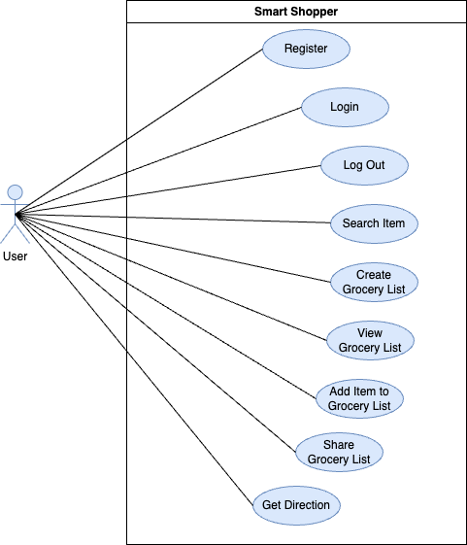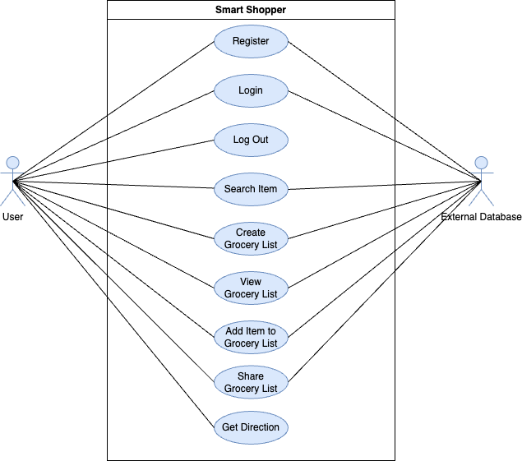

Figure 4: Use Case Diagram

### Use Case Description

A Use Case Description is a scenario-written outline of stages of collaboration between an actor (a member of a user group) and the system (*What Is Use Case Diagram?* n.d.).

For the Smart Shopper application, use case descriptions were made for all use cases, for example, “search for products”, and “get directions”.

#### Example of Search Item

|  |  |
| --- | --- |
| **ID** | 11 |
| **Name** | Search Item |
| **Description** | This use case allows users to search for specific grocery products within the application. |
| **Actor** | User |
| **Precondition** | - |
| **Scenario** | 1. User enters a product name or keyword in the search bar. 2. The application displays a list of products matching the search query. 3. User selects a product from the list to view more details. |
| **Exceptions** | If no results match the search query, the application displays a message indicating that no products were found. |
| **Extensions** | None |
| **Postconditions** | User can view product details. |

Table 6: Search Item

Below search item sequence diagram is only for review now.

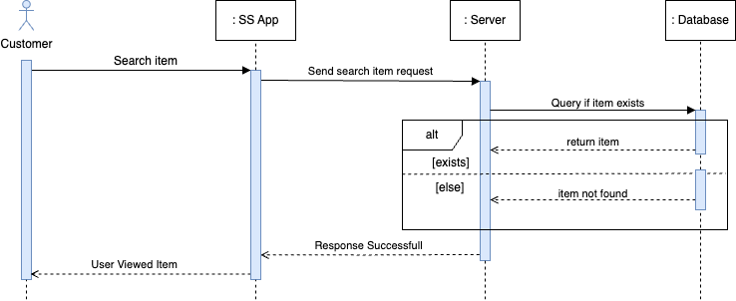

#### Example of Get Direction

|  |  |
| --- | --- |
| **ID** | 3 |
| **Name** | Get Direction |
| **Description** | The "Get Direction" use case within the Smart Shopper application focuses on allowing users to reach their desired supermarkets efficiently. This functionality uses geolocation services to guide users to the selected supermarkets based on their preferences and the information available. |
| **Actor** | User |
| **Precondition** | The user has a registered Smart Shopper account.  The user has provided location access to the Smart Shopper application.  The user has selected an item from the application. |
| **Scenario** | 1. The user selects a specific item/s and initiates a request for directions. 2. The Smart Shopper application retrieves the user's location using GPS services and identifies the selected supermarket as the destination point. 3. The application calculates the optimal route to reach the destination using real-time mapping and navigation services. 4. The calculated route, along with step-by-step directions, is presented to the user within the application interface. |
| **Exceptions** | **GPS Unavailable:**  If the GPS service is unavailable, the application informs the user and suggests enabling location services.  **Connection Issues:**  In case of connectivity issues with mapping services, the application informs the user about the problem and recommends trying again later. |
| **Extensions** | None |
| **Postconditions** | * The user receives accurate and up-to-date directions to the selected supermarket. * The application may offer additional features during navigation, such as nearby points of interest or alternative routes. |

Table 7: Get Direction

## Activity Diagrams

Activity diagrams were created for the Smart Shopper project to illustrate how each use case's events progressed. Every activity diagram consists of a series of activities that represent the tasks completed in the use case and transitions that illustrate the transfer of control between activities. A flowchart and an activity diagram are similar in that they show the steps of a process and their timing.

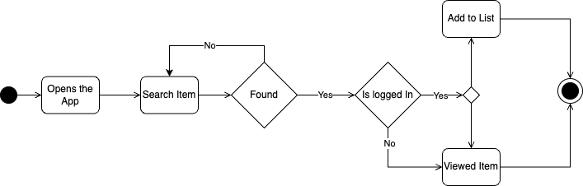

Figure 5: Search Item Activity Diagram

## Sequence Diagrams

To model the interactions between the application components, sequence diagrams were used. A sequence diagram, for instance, was developed to show the progression of events that take place when a person registers. In Figure 4 shows how the Smart Shopper App interacts with the User and initiates actions based on user interactions. The Server receives requests from the app and interacts with the Backend API. The Backend API communicates with the OSRM API to fetch route information. The fetched information is then processed and displayed by the Smart Shopper app.

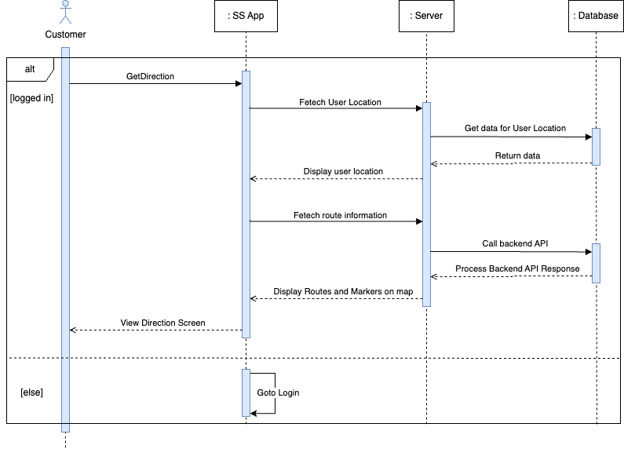

Figure 6: Get Direction Sequence Diagram

## Data Requirements

Data requirements are about the data used and produced throughout the procedure of achieving a goal by users.

### Data Dictionary

A unified source of metadata or an all-term glossary for an application domain during the analysis phase. The main purpose of creating it is to understand the terms of analyzing it before starting to design data modeling. The following Table 6 has been used as its user data.

User Data:

|  |  |  |
| --- | --- | --- |
| **Data:** | **Type:** | **Description:** |
| User ID | Numeric | A unique identifier for each registered user. |
| Username | Alphanumeric | The chosen username of the user. |
| Email | String (Email Format) | The email address associated with the user's account. |
| Password | String (Hashed) | The user's password for account authentication. |

Table 8: User Data Dictionary

### Data Constraints

Data constraint explains DO and DON’T in the value assortment of attributes and entities while analyzing, constraints are verbally explained. The following Table 7 has been demonstrated as its example.

|  |  |  |
| --- | --- | --- |
| **Data:** | **Description:** | **CONSTRAINS TYPE** |
| User ID | A unique identifier for each registered user. | Numeric, auto-increment, unique. |
| Username | The chosen username of the user. | Alphanumeric, 4-20 characters, unique. |
| Email | The email address associated with the user's account. | Valid email format, unique. |
| Password | The user's password for account authentication. | At least 8 characters, a mix of upper- and lower-case letters, numbers, and special characters. |
| Grocery List ID | A unique identifier for each user's grocery list. | Numeric, auto-increment, unique. |
| Product Name | The name of a grocery product. | Alphanumeric, 2-50 characters. |
| Product ID | A unique identifier for each grocery product. | Numeric, auto-increment, unique. |
| Product Price | The price of a grocery product in euros. | Numeric, two decimal places. |
| Supermarket Name | The name of a supermarket or store. | Alphanumeric, 2-100 characters. |
| Supermarket Location | The physical location (address) of a supermarket. | Alphanumeric, up to 255 characters. |
| User Location | The user's current geographical location. | Latitude and longitude coordinates. |
| Product Image | An image representing the grocery product for a user-friendly UI. | Image file format (e.g., JPG, PNG). |

Table 9: Data Constraints

# Research

## Introduction

This chapter studies several API choices and other alternative methods while assessing their applicability to the project. Based on the research findings, recommendations on the best method(s) to utilize are made after discussing the benefits and drawbacks of each strategy.

## Literature Review

To start the project effectively, and to answer, *“How can the Smart Shopper application enhance and optimize the grocery shopping experience for expatriates, considering factors such as efficiency, cost-effectiveness, and user satisfaction?”* the available APIs and alternative data sources for Dutch grocery stores were thoroughly observed. These APIs offer a more reliable and flexible way to gather product information compared to web scraping. The primary goal was to find the best data sources for products, deals, and prices at major Dutch supermarkets. This information will be a vital part of the Smart Shopper app, offering expats accurate and up-to-date details.

In the initial project phase, extensive research was conducted on supermarket APIs to evaluate their suitability for project’s goals. Various API options and web scraping alternatives were discovered, ensuring they fit the project's needs. This chapter presents these options, discusses their pros, and cons, and offers recommendations for the best approach to use in the Smart Shopper app.

## APIs

To answer the sub-question “*What APIs are available that provide data on different products at several grocery stores in the Netherlands?”.* The below APIs help shape the project's direction and determine the technical architecture for retrieving supermarket data, a critical component of the Smart Shopper application. There are many other APIs and data sources available here are a few to consider for the Netherlands markets:

1. Checkjebon API
2. ShoppingScraper API
3. Superscanner API
4. Websrapping.Amsterdam API

In assessing the mentioned APIs, the following standards were considered based on the requirements:

* Which format/s allows for the exploration of data?
* Is there a broad range of products and retailers covered by the API's data?
* What is the price of utilizing the API?

### Checkjebon API

Checkjebon API is designed for price comparison and product information retrieval. It allows developers to access and use data related to various products from different sources1. It’s an open-source project the data can be used freely1. The API contains the data in JSON format. It is free to use and other pricing details for API usage are available on the website. It offers different subscription tiers though1. The API covers a range of products, including grocery items from various supermarkets and some of them are as follow1: Albert Heijn, Aldi, Coop, DekaMarkt, Dirk, Hoogvliet, Jan Linders, Jumbo, Plus, SPAR, and Vomar.

### Shopping Scraper API

Shopping Scraper API is a web scraping service designed for retrieving product info, product images, and price information from various online retailers. It allows developers to access and integrate scraped data into their applications. The API provide the data in JSON format. The API does not specifically mention a list of NL grocery stores. It appears to focus on online retailers in general. But it contains data for below NL supermarkets: Alber Heijn, Jumbo.

Pricing details are available on the website as below. It offers a free tier with limited usage.

* Essential: €129/mo
* Growth: €199/mo
* Advanced: €399/mo
* Enterprise: €749+/mo

### Superscanner API

Superscanner API is a price comparison service that allows users to compare prices of various products across different online stores. It provides developers with access to its data. The API provide the data in JSON format. Pricing details are not available on their website. While the API focuses on various products, it does include a category for grocery products of the supermarkets as follows: Albert Heijn, Jumbo, Makro, Dirk, Nettorama, PicNic, Plus, Spar, and Hoogvliet.

### Websrapping.Amsterdam API

Websrapping.Amsterdam offers web scraping services for various types of data, including product and price information. It allows developers to access and retrieve data from websites (*Bekijk Alle Datasets – Webscraping Amsterdam*, n.d.). it provides the data in JSON format. Pricing details for API usage are available on the website, including different pricing tiers.

The API's focus is not specifically mentioned, but it appears to cover a broader range of websites rather than being limited to grocery stores and they are as follow: Albert Heijn, Jumbo, Coop, Lidl, Plus, Ekoplaza, and Dirk.

## APIs Pro’s and Con’s

|  |  |  |
| --- | --- | --- |
| API | Advantages | Disadvantages |
| Checkjebon API | - Allows users to compare prices of various products across different Supermarkets.  - Data provided in JSON format for easy integration.  - Dail updates based on data from online stores.  - Offers a free tier with rate limits.  - Access is secured using an API key.  - Covers a range of product categories. | - Data accuracy may vary based on the availability and accuracy of data from online stores.  - Limited user reviews and a relatively smaller user base.  - Documentation may not be as comprehensive as some other APIs. |
| ShoppingScraper API | - Provides access to scraped product and price data from various online retailers.  - Offers data in JSON format for easy integration into applications.  - Regularly updates data based on changes in source websites.  - Offers a free tier with limited usage, making it cost-effective for small projects.  - Secured access using an API key.  - Developer support via email. | - Accuracy of scraped data may vary depending on source websites.  - Basic documentation may require additional effort for integration.  - Smaller user community and limited user reviews.  - Limited coverage and focus on specific types of products. |
| Superscanner API | - Allows users to compare prices of various products across different online stores.  - Data provided in JSON format for easy integration.  - Regular updates based on data from online stores.  - Offers a free tier with rate limits.  - Access is secured using an API key.  - Covers a range of product categories. | - Data accuracy may vary based on the availability and accuracy of data from online stores.  - Basic documentation.  - Limited user reviews and a relatively smaller user base.  - Documentation may not be as comprehensive as some other APIs. |
| Websrapping.Amsterdam API | - Offers web scraping services for various types of data.  - Provides data in JSON format.  - Regular updates based on changes in source websites.  - Offers different pricing tiers.  - Secured access using an API key.  - Developer documentation provided. | - Focus may not be specific to grocery stores; covers a broader range of websites.  - Data accuracy may vary based on the source websites.  - Limited user reviews and a smaller user community.  - Documentation may require additional effort for integration. |

## 

## Methodology

The API research provided the following key findings:

* **Availability**: Several major supermarket chains, including Albert Heijn, Jumbo, Makro, and Dirk offer APIs or data feeds for accessing pricing and product information.
* **Documentation**: API documentation for Albert Heijn, Jumbo, Makro, and Dirk are available, providing details on endpoints, data formats, and usage guidelines.
* **Technical Feasibility:** Initial assessments indicate that integrating these APIs into the Smart Shopper mobile application is technically feasible.

The API research was conducted systematically and included the following steps:

* **Online Research:** I began by determining the data requirements for the Smart Shopper application, focusing on obtaining pricing and promotion data from Dutch supermarkets.
* **API Documentation Review:** When potential APIs were identified, I meticulously reviewed their documentation to evaluate their suitability for our project's objectives.
* **Technical Feasibility:** The technical feasibility was assessed of integrating the identified APIs into the mobile application. Factors such as data accessibility, accuracy, integration complexity, cost, and support were considered.

## API Result

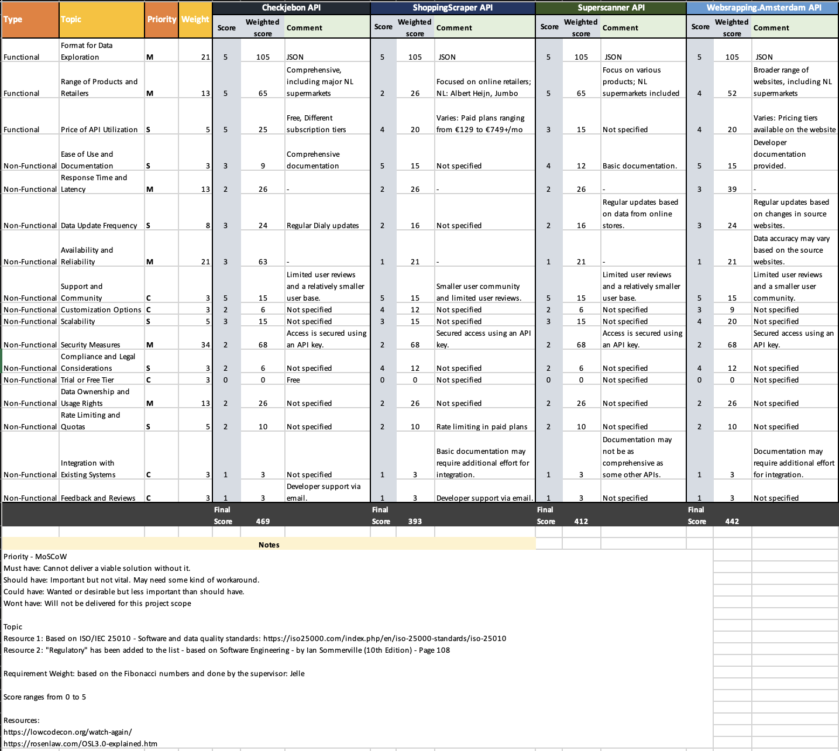

Figure 7: APIs Result

The Checkjebon API is the most appropriate API for the project based on the evaluation above in Figure 7 and client preferences. It offers information about the products, costs, and offers at the largest supermarkets in the Netherlands. The API is also rather simple to use and works nicely with the application. Utilizing the API comes free of price.

The constraints of the other APIs considered made them less suitable for the purpose. For instance, both the Webscraping and the ShoppingScraper API only provided a very limited amount of coverage for Dutch grocery stores. Amsterdam API, which was also the most expensive API, offered data in a format that was not acceptable for the application. We also explored the possibility of web scraping if the available APIs did not meet our criteria.

## Conclusion

The Checkjebon API is the preferred choice over web scraping, according to APIs research done on data-collecting techniques for the Smart Shopper application. This research’s primary goal was to determine the best approach for gathering product data from at least important significant Dutch grocery stores to support the Smart Shopper application.

An evaluation of various APIs led to the conclusion that the Checkjebon API was the most suitable for the project due to its wide coverage of stores and products in the Netherlands, ease of use, and affordability. However, its limitation of lacking data on getting the images for the products for which Albert Heijn API has been used. Therefore, some of the products will not have images.

In conclusion, considering the effort required to collect data from various sources and the time allotted for the graduation internship, the Checkjebon API was chosen over web scraping. This methodology facilitates the development of a sturdy and efficient Smart Shopper application and offers avenues for more investigation into data collection techniques and their efficacy for certain uses.

# Design

The design phase is a plan or an overview of an object for its construction or implementation of a process or an activity for all its stages. What features and functionality bring the Smart Shopper will also answer the sub-question “*What features and functionalities should be prioritized in the Smart Shopper application to ensure a seamless and user-friendly experience for expatriates?* “. There are important steps to achieve a goal for better design and constraints, may consider visual, practical, socio-political, or financial considerations, and might combine certain settings. This phase entails developing a design that forms the application's aesthetic look, functionality, and general features.

## Functional Design

Functional design is used as a model to simplify hardware and software device designs like 3D modeling and software models. Each modular also ensures the functionality assigned to the part to decrease the side effects of its responsibility to the minimum level it can (*Functional Design Specification*, 2018).

### Wireframe Design

Wireframe design is the process of the appearance of a page/screen and selecting the right color scheme, proper layout with appropriate font with correct text size. Every screen has its font, color, layout, and design, but in general, all pages should have a similar graphic design. The following Figure 8 demonstrates as example.

The accomplished user interface features an easy-to-use navigation mechanism, clear fonts, and color options. The layout was also designed with accessibility in mind, ensuring that a wide range of users, including those with visual impairments, could use the application.

In conclusion, the UI design strategy was critical to developing an application that is visually appealing and simple to use, resulting in a great user experience. As the program continues to develop, the design will be improved to ensure that it fulfills user expectations and requirements.

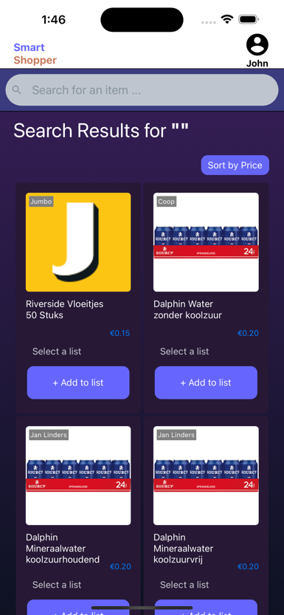

Figure 8: Search Wireframe

### Navigation Diagram

Navigation diagram main purpose is to demonstrate the navigation from a home page to the other pages as shown in the Figure 9, whereas pages are shown as individual window or page, with the page name above. Arrows have been used to point out the navigation from one page to another and shows navigation between all pages.

To get this several design tools like draw.io and Figma were used to create the application's user interface. Figma and draw.io enabled the building of a design framework and the establishment of a uniform visual language throughout the application. The UI design process started with wireframes, which show how the program would look and how different screens would interact with one another. These wireframes served as the foundation for the UI design, with design specialists advising on design decisions.

The Smart Shopper app wireframes were made to show the structure of the home page, search page, and other pages, as well as how they relate to one another. The home page presents “list, create list, search bar to look for products and best deals”. The user can navigate to the search page by entering a key or item name in the search bar on home page.

The search page allows the user to look for items by their names. The user may go return to the home page to browse other promotions or pick a product to examine its information or add it to their list. The list page displays all the products that the user has added to their list. From this page, the user can get the distance of the supermarkets and the “Get Direction” feature to the selected supermarket's products. Account page allows to edit expat's personal information.

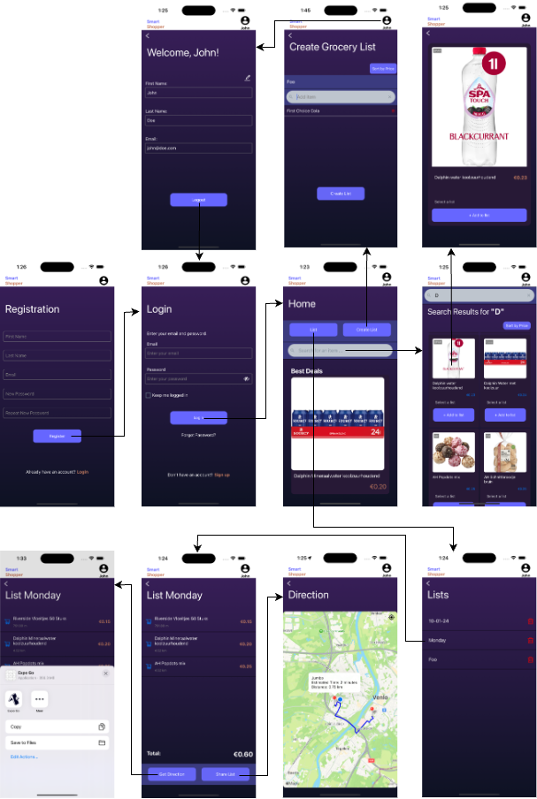

Figure 9: Navigation Diagram

## Visual Design

Visual design is the use of imager font, color, layout, design, typography, and shape forms to increase and improve the usability of experiences1. Fields like UI design and graphic design have grown out instantly[3].

### Moodboard

A Moodboard is an arrangement of images or creative composition of pictures, material pieces of text elements intended concept to present an atmosphere2. A Moodboard is also used to clarify equivocal, which are hard to explain ideas or generate ideas for the designer and the collation customer. As an example, below Figure 7 represents the combination of images, color, and font used together for the windows design.



Figure 10: Moodboard

## Technical Design

Technical design is a solution to the activities and its problem while developed designed has been completed. A designer co-ordinates technical design before even actual design begins (*Technical Design Stage for Building Projects*, n.d.).

### ER Diagram

The ER diagram for the Smart Shopper app shows the association of key information within the system. The main entities include Users, Products, Stores, and Lists also shown in Figure 11. Users are characterized by their first names, last names, emails, and passwords. Products encompass details such as names, prices, and categories. Stores are defined by names and locations, while Lists involve names and are associated with specific users. The ER diagram visually represents these entities as boxes, highlighting the attributes they contain. Relationships between entities are indicated by lines, depicting associations like users having multiple lists, each list being connected to a single user. Also, products are linked to stores and can be part of several shopping lists. The ER diagram confirms a clear understanding of data connections, helping in the actual design and implementation of the Smart Shopper app.

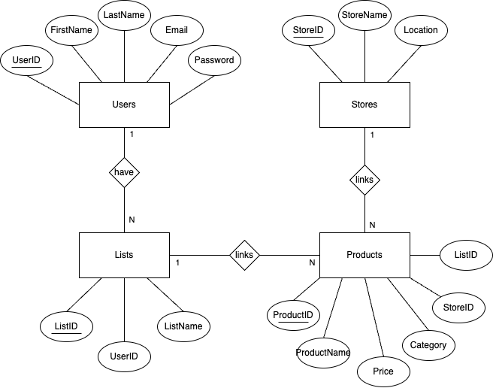

Figure 11: ER Diagram

### Relational Model

The Relational Model is a way of handling the data and it structure consistency, where all data is characterized as group into relation in terms of tuples. In the below example Figure 8: Relational Model has been illustrated with its primary keys and foreign key.

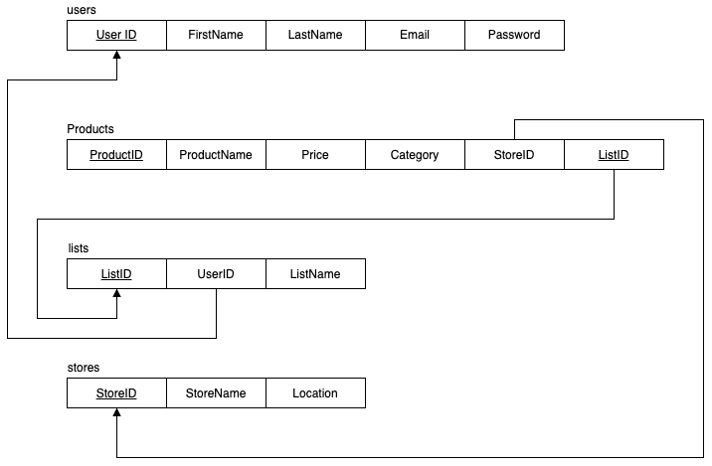

Figure 12: Relational Model

### Database Schema

A database schema is a blueprint of a structure and design and its constraint and relation. The very core stage of creating any software or webpage. Below Table 10 depict how it were generated.

#### Users Table:

|  |  |
| --- | --- |
| **Key** | **Description** |
| **UserID (Primary Key):** | A unique identifier for each user. |
| **FirstName:** | The user's chosen first name. |
| **LastName:** | The user's chosen last name. |
| **Email:** | The user's email address. |
| **Password:** | An encrypted version of the user's password. |

Table 12: User Database Schema

# Implementation

This chapter discusses the present state of the Smart Shopper application's implementation, including the programming languages used, the development frameworks selected, and other technical details.

## Architecture

For the Smart Shopper app, the team's familiarity with these architectures, and expectations for future growth are very important[4]. Few of them relate to the Smart shopper are below:

1. MVC (Model-View-Controller)4:
2. MVP (Model-View-Presenter)4:
3. MVVM (Model-View-ViewModel)4:
4. VIPER (View-Interactor-Presenter-Entity-Routing)4:

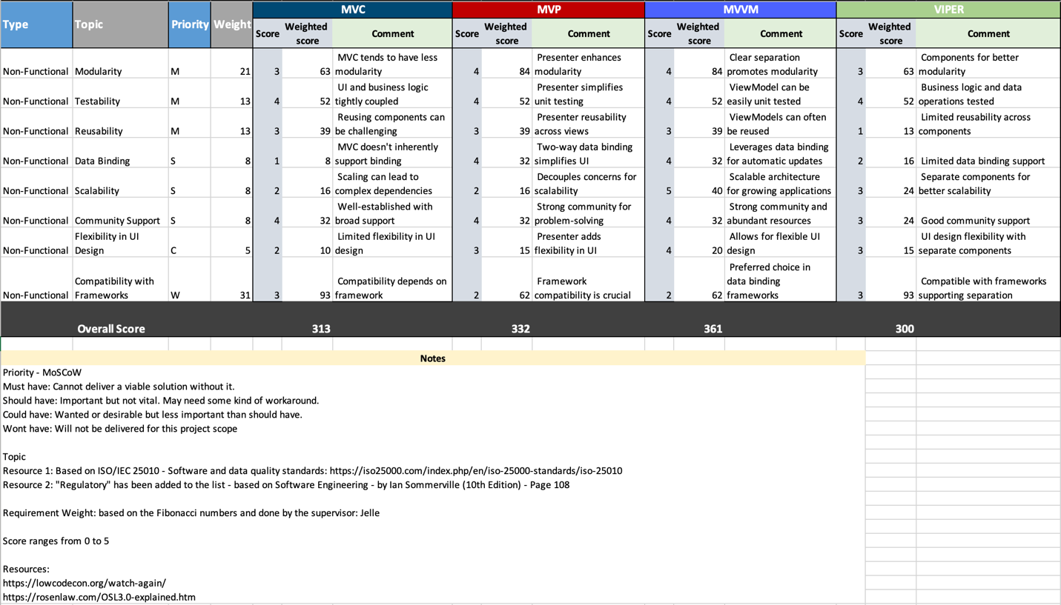

Figure 13: Architecture Comparison

MVVM (Model-View-ViewModel) architecture is a well suited for the Smart Shopper project due to its clear separation of concerns, modularity, testability, reusability, and support from a thriving development community as shown in Figure 13. This architecture provides the necessary structure and flexibility for managing complex user interfaces and business logic (Michaelstonis, 2022).

## Stack

### Mobile Frontend:

#### React Native:

If you would like a cross-platform approach with a single codebase, React Native is a well-liked option as full evualuation is shown in . It allows you to build native-like mobile apps using JavaScript and React6. Comparing React Native with other frameworks like Flutter or Xamarin, React Native stands out as the best choice for the Smart Shopper project due to its broader community support, extensive library of pre-built components, and compatibility across both iOS and Android, which optimizes development time and costs[5].

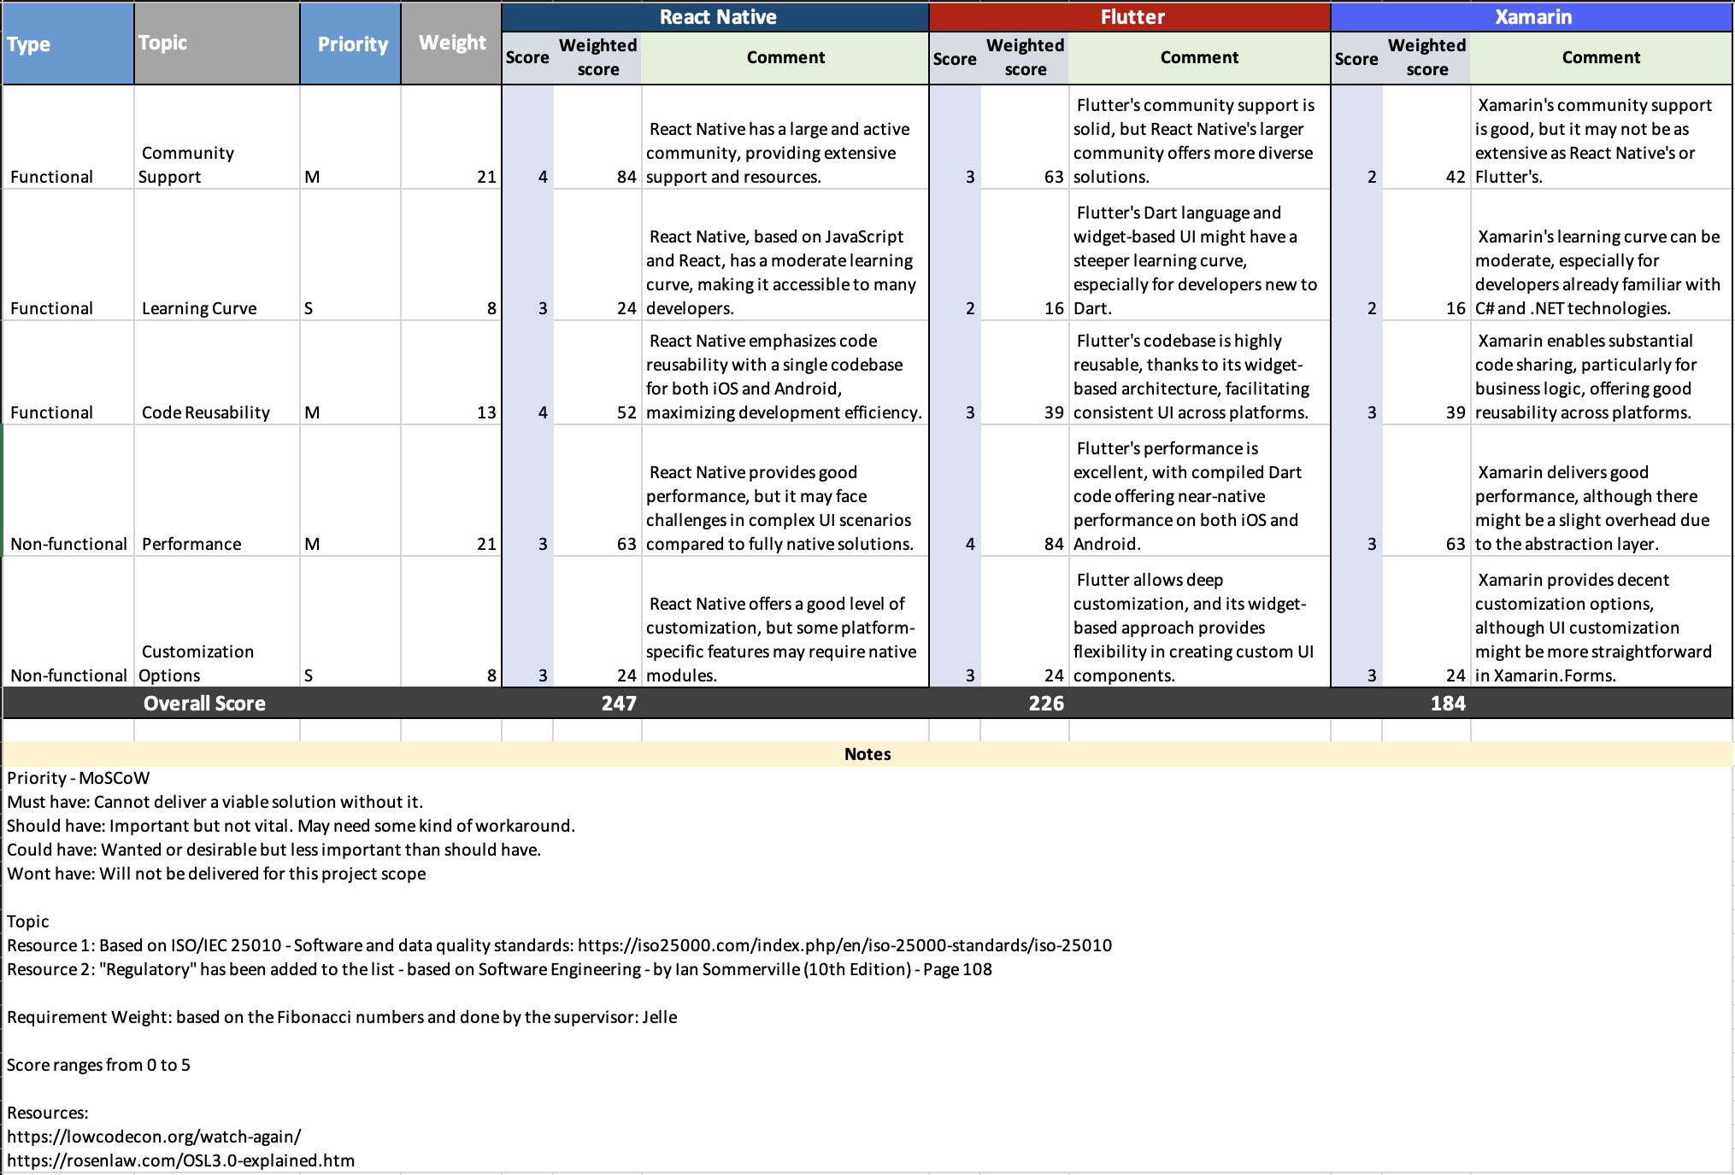

### Backend Development:

#### JavaScript:

JavaScript, in contrast to languages like C++ and Python, is well-suited for web and mobile app development due to its unique ability to run directly in web browsers9. This feature enhances user experience, providing a more responsive and interactive interface, making it a preferred choice for Smart Shopper[6].

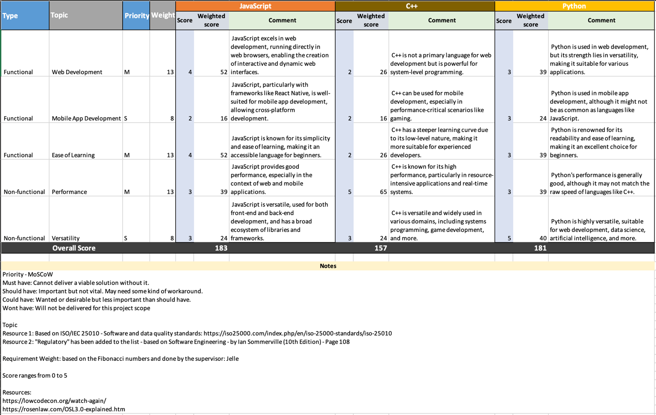

Figure 14: Backend Development

#### Node.js

The Smart Shopper application's backend is built using Node.js, which offers a strong and effective runtime environment for handling real-time operations (Khare, 2023).

#### API Integration:

**Express.js**: For building RESTful APIs that connect the app to external data sources like Checkjebon API.

Pros:

* Wider adoption and more resources are available[7].
* Easier for developers already familiar with JavaScript10.
* Quicker prototyping and development due to its dynamic nature10.
* The company uses JavaScript10.

Cons:

* Less strict type checking, which can lead to runtime errors10.
* Slower10.

### Database:

#### SQLite

It is a database engine written in the C programming language. Many programming languages have bindings to the SQLite library. It generally follows PostgreSQL syntax but does not enforce type-checking by default[8].

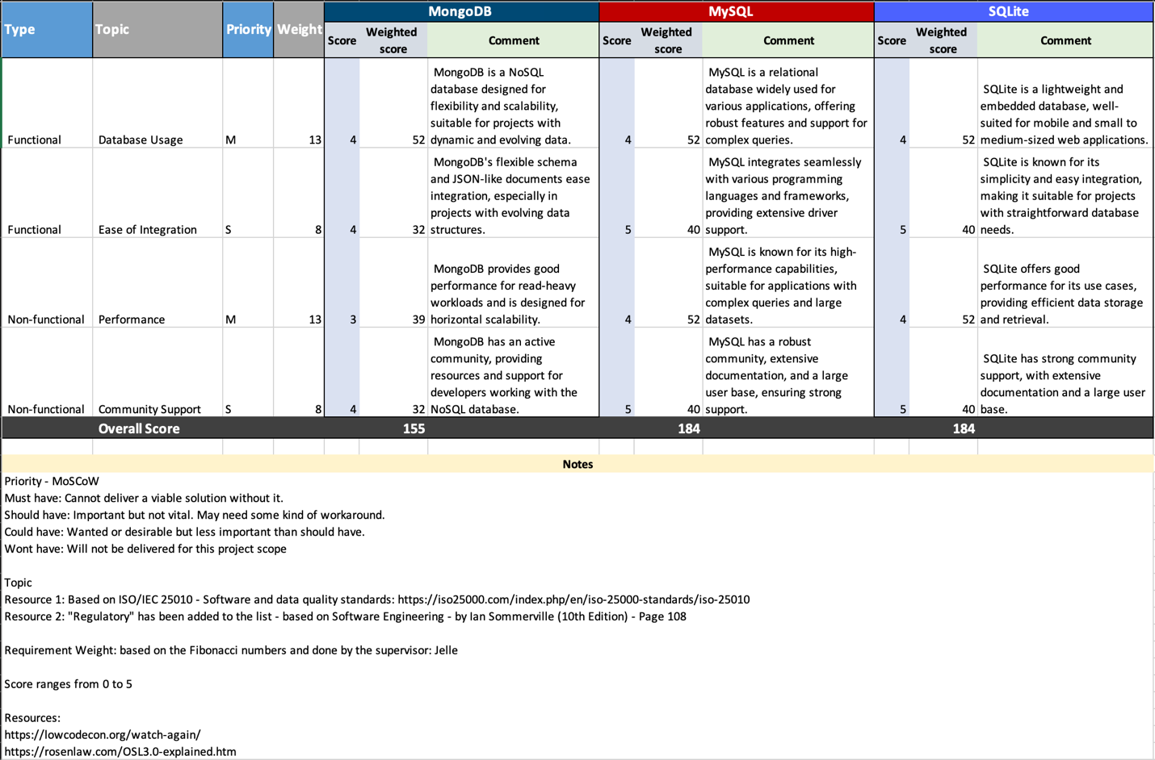

Figure 15: Database

### Version Control:

#### Git:

* Use Git for version control to track changes in your codebase and collaborate with the development team effectively[9]
* GitHub (Project Board)

The choice of Stack or its frameworks depends on various factors, including the project's specific requirements, team expertise, and development preferences. Each framework offers unique advantages and is suited to different use cases. The above stack is suitable based on the requirements and personal experience with the stack.

# Advice

## Continuous Improvement

Considering that Smart Shopper is an innovative approach, new methods to increase user adoption must be considered. This includes user education programs, targeted advertising efforts, and even collaborations with supermarkets providing real-time product information and promotional events.

Emphasize the value of using an iterative development process. Encourage CGI to include review features in the program so that it can collect user data. It is important to schedule regular updates to improve functionality, fix problems, and stay in step with changing user requirements.

## Data Security and Privacy Compliance

Emphasize how important it is to protect user privacy and data. Recommend continuous monitoring and adherence to data protection regulations. Suggest implementing robust security measures such as encryption and secure authentication protocols.

## Scalability Planning and Integration Opportunities

Considering potential future growth, CGI should plan for scalability. The application should be designed to handle increased user loads and expanded functionalities. Scalability is crucial to accommodate a growing user base and evolving market demands.

Explore possibilities for integration with other platforms or applications. Seamless integration with popular platforms can enhance user convenience. For instance, integration with digital payment systems or loyalty programs could further elevate the user experience.

## Agile Project Management

Encourage the continued use of agile project management methodologies. This iterative approach allows for flexibility in responding to changes in requirements and market dynamics, ensuring that Smart Shopper remains adaptable and responsive.

Suggest fostering strong collaborations with supermarkets. This can lead to mutual benefits, such as exclusive deals for Smart Shopper users and increased visibility for supermarkets.

# Conclusion

To conclude during the internship, noticeable progress on the Smart Shopper app was made. It all started with the requirement-gathering phase. Here, important features were identified in what the app should do, both in terms of basic functionality and other important aspects. Fancy tools like use case diagrams to show the different parts of the app and how they all fit together are used.

To outline better, the project started with an analysis phase, where plans and approaches were set up to guide the implementation process. The research was conducted to evaluate various APIs and web scraping techniques, leading to the selection of the most suitable methods for acquiring accurate and reliable data for products, promotions, and prices from major grocery stores in the Netherlands.

The analysis and research laid the foundation for the design process, which helped in creating wireframes, UI designs, system architectures, and comprehensive software designs. This part laid the basis required for the application to be implemented successfully.

Research on APIs was performed. Mainly, to identify best way of getting data from the grocery stores. After proper research customer preference, using the Checkjebon API was the reasonable choice. It fits well with what the app needs to do, and it matches the tight schedule of the project.

During the implementation phase, all the planned use cases were developed, including search products, compare prices, filter on search result, add to list, and many more. When the actual implementation of the app started, there were some challenges in getting the search functionality and store locator feature to work seamlessly. These challenges were tackled by teaming up with colleagues and getting some advice from the client.

The Smart Shopper app implementation is the focus for the future. There are other exciting features to work on, including lists, search keywords, routing, supermarket location, and account setup. These features help expatriates stay organized and find more cheap deals based on their preferences.

For the most part, CGI international employees have found the Smart Shopper application to be a useful tool thanks to its successful development. Still, before the application is finally published, it is necessary to investigate the recommendation that is given in the advice chapter. It provides dependable guidance on how to improve the application.

# Reference

Amazon Web Services, Inc. Retrieved April 9, 2021, from https://aws.amazon.com/amazon-mq/?amazon-mq.sort- by=item.additionalFields.postDateTime&amazon-mq.sort-order=desc

Analytics India Magazine. https://analyticsindiamag.com/9-best-kubernetes- alternatives-for-devops-engineers/

*Bekijk alle Datasets – Webscraping Amsterdam*. (n.d.). https://webscraping.amsterdam/data-producten/

Cardello, J. (2023, October 22). *The web design process: creating the visual design*. Webflow. https://webflow.com/blog/the-web-design-process-creating-the-visual-design?utm_source=google&utm_medium=search&utm_campaign=SS-GoogleSearch-Nonbrand-DynamicSearchAds-Global&utm_term=aud-936979375361:dsa-1537217525485___617245336969__&gclid=CjwKCAjws9ipBhB1EiwAccEi1DD-Wf9lkxyQbhit3Gt2HmEH23QilfKha1f_RWqTcE9Ou4k8HblfdRoCUSYQAvD_BwE

 Chacon, Scott; Straub, Ben (2014). ["Git on the Server – Setting Up the Server"](https://git-scm.com/book/en/v2/Git-on-the-Server-Setting-Up-the-Server). Pro Git (2nd ed.). Apress. [ISBN](https://en.wikipedia.org/wiki/ISBN_(identifier)) [978-1484200773](https://en.wikipedia.org/wiki/Special:BookSources/978-1484200773).

*Company overview*. (n.d.). CGI. https://www.cgi.com/en/overview

Cooper, A. (2023, October 6). Detailed Comparison Between flutter, react native & Xamarin. *ValueCoders | Unlocking the Power of Technology: Discover the Latest Insights and Trends*. https://www.valuecoders.com/blog/technology-and-apps/flutter-vs-xamarin-vs-react-native-which-cross-platform-mobile-app-development-framework-to-choose/#:~:text=Flutter%2C%20React%20Native%2C%20and%20Xamarin%20Frameworks%20are%20competent%20at%20developing,terms%20of%20seamless%20user%20experience.

ECMAScript® 2020 Language Specification. Archived from the original on 2020-05-08. Retrieved 2020-05-08.

*Functional Design specification*. (2018, March 27). Scott Manning. https://scottmanning.com/content/functional-design-specification/

Khare, M. (2023, October 18). *What is Node.Js and why you should use it*. Kinsta®. https://kinsta.com/knowledgebase/what-is-node-js/#:~:text=In%20a%20nutshell%2C%20Node.,and%20data%20streaming%20applications%2C%20too.

Kumar, A. (2023, September 25). Why React Native is Better than Other Similar Platforms? *YourTimeIndia*. https://www.yourteaminindia.com/blog/why-react-native-is-better-than-other-platforms#:~:text=and%20Android%20platforms.-,It%20is%20easy%20for%20web%20developers%20to%20transition%20to%20mobile,many%20libraries%20and%20tools%20available.

Michaelstonis. (2022, November 4). *Model-View-ViewModel - .NET*. Microsoft Learn. https://learn.microsoft.com/en-us/dotnet/architecture/maui/mvvm

Most Widely Deployed SQL Database Estimates". SQLite.org. Retrieved May 11, 2011.

Owens, Michael (2006). "Chapter 4: SQL". In Gilmore, Jason; Thomas, Keir (eds.). The 8Definitive Guide to SQLite. D. Richard Hipp (foreword), Preston Hagar (technical reviewer). Apress. p. 133. ISBN 978-1-59059-673-9. Retrieved 30 December 2014.

PlantUML. (n.d.). *Use case Diagram syntax and features*. PlantUML.com. https://plantuml.com/use-case-diagram

Supermarkt. (n.d.). *GitHub - supermarkt/checkjebon: Dutch supermarket prices and comparison tool*. GitHub. https://github.com/supermarkt/checkjebon

Team, D., Team, D., & Team, D. (2023, May 11). *Advantages and Disadvantages of ExpressJS*. DataFlair. https://data-flair.training/blogs/expressjs-advantages-and-disadvantages/

*Technical design stage for building projects*. (n.d.). Designing Buildings. https://www.designingbuildings.co.uk/wiki/Technical_design_stage_for_building_projects

Triare Ukraine. (2023, June 13). *Architecture for Mobile Apps: MVC vs MVP vs MVVM vs Viper*. TRIARE. https://triare.net/insights/common-architecture-for-mobile-application/

Usage Statistics of JavaScript as Client-side Programming Language on Websites, July 2023. w3techs.com. Retrieved 2023-07-02.

*What is Use Case Diagram?* (n.d.). https://www.visual-paradigm.com/guide/uml-unified-modeling-language/what-is-use-case-diagram/

Wikipedia contributors. (2023, September 15). *Users’ group*. Wikipedia. https://en.wikipedia.org/wiki/Users%27_group

Wordsmith, K. (2023, January 11). Decoding the secrets of top programming languages: JavaScript, Python, Java, C#, and C++. Medium. https://medium.com/@keyboardwordsmith/decoding-the-secrets-of-top-programming-languages-javascript-python-java-c-and-c-8b184f966bb7#:~:text=JavaScript%20is%20a%20good%20choice,such%20as%20system%20programming%20and

# Appendix

**Gantt chart**

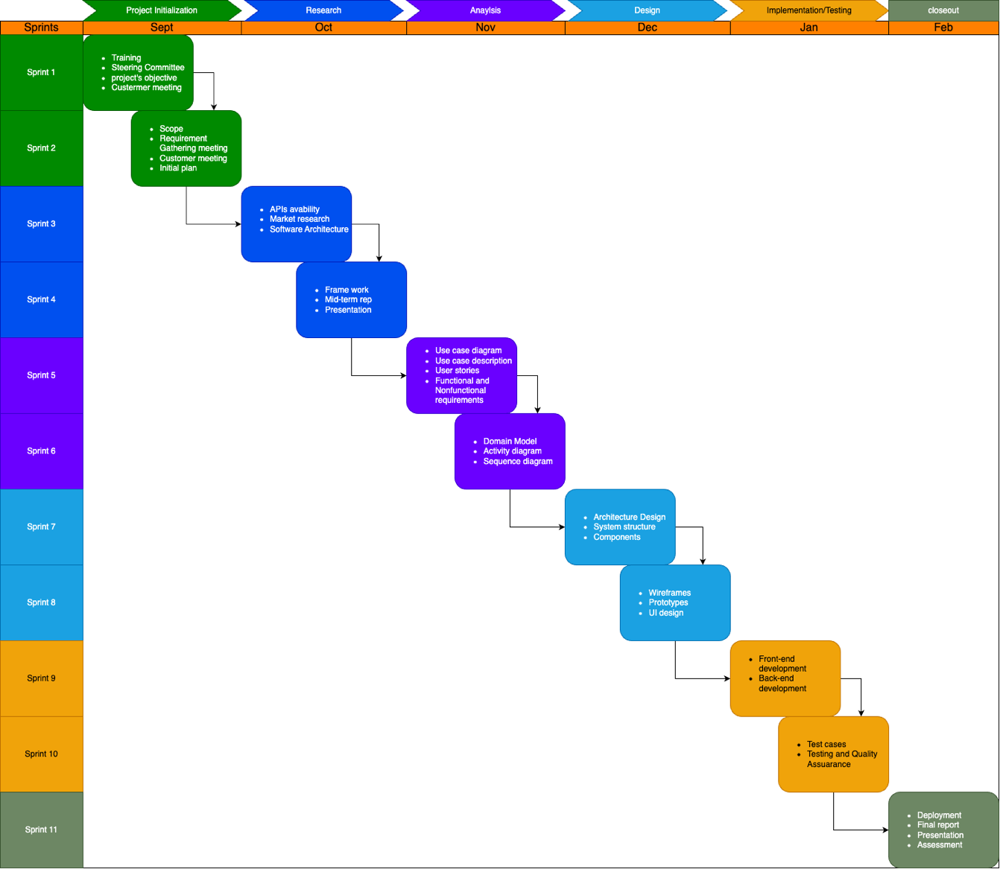

**Data Dictionary**

|  |  |  |
| --- | --- | --- |
| Grocery Data | | |
| Data: | Type: | Description: |
| Grocery List ID | Numeric | A unique identifier for each user's grocery list. |
| Product Name | Alphanumeric | The name of a grocery product. |
| Product ID | Numeric | A unique identifier for each grocery product. |
| Product Price | Decimal | The price of a grocery product in euros. |

Table 13: Grocery Data Dictionary

|  |  |  |
| --- | --- | --- |
| Supermarket Data | | |
| Data: | Type: | Description: |
| Supermarket Name | Alphanumeric | The name of a supermarket or store. |
| Supermarket location | Alphanumeric | The physical location (address) of a supermarket. |

Table 14: Supermarket Data Dictionary

|  |  |  |
| --- | --- | --- |
| Location Data | | |
| Data: | Type: | Description: |
| Location Data | Geographic Coordinates (Latitude, Longitude) | The user's current geographical location. |

Table 15: Location Data Dictionary

|  |  |  |
| --- | --- | --- |
| Product Image Data | | |
| Data: | Type: | Description: |
| Product Image | File (Image) | An image representing the grocery product for a user-friendly UI. |

Table 16: Product Image Data Dictionary

**Database Schema**

**Products Table:**

|  |  |
| --- | --- |
| Key | Description |
| ProductID (Primary Key): | A unique identifier for each product. |
| ProductName: | The name of the product. |
| Price: | The price of the product. |
| Category: | The product's category (e.g., groceries, electronics, clothing). |
| StoreID: | A foreign key that links to the store where the product is available. |
| ListID: | A foreign key that links a product to a list. |

Table 17: Products Database Schema

**Stores Table:**

|  |  |
| --- | --- |
| Key | Description |
| StoreID (Primary Key): | A unique identifier for each store. |
| StoreName: | The name of the store. |
| Location: | The location or address of the store. |

Table 18: Stores Database Schema

**List Table:**

|  |  |
| --- | --- |
| Key | Description |
| ListID (Primary Key): | A unique identifier for each list. |
| UserID: | A foreign key that links to the user who created the list. |
| ListName: | The name of the list. |

Table 19: List Database Schema

**Relationships:**

* Users have a one-to-many relationship with lists, allowing a user to create multiple lists.
* Products have a many-to-many relationship with stores, as a product can be available in multiple stores, and a store can offer multiple products.
* Users also have a one-to-many relationship with lists through the UserID field.

**Foreign Keys:**

* The UserID in the lists table links each list to a specific user.
* The StoreID in the Products table connects each product to a particular store.

**Wireframes**

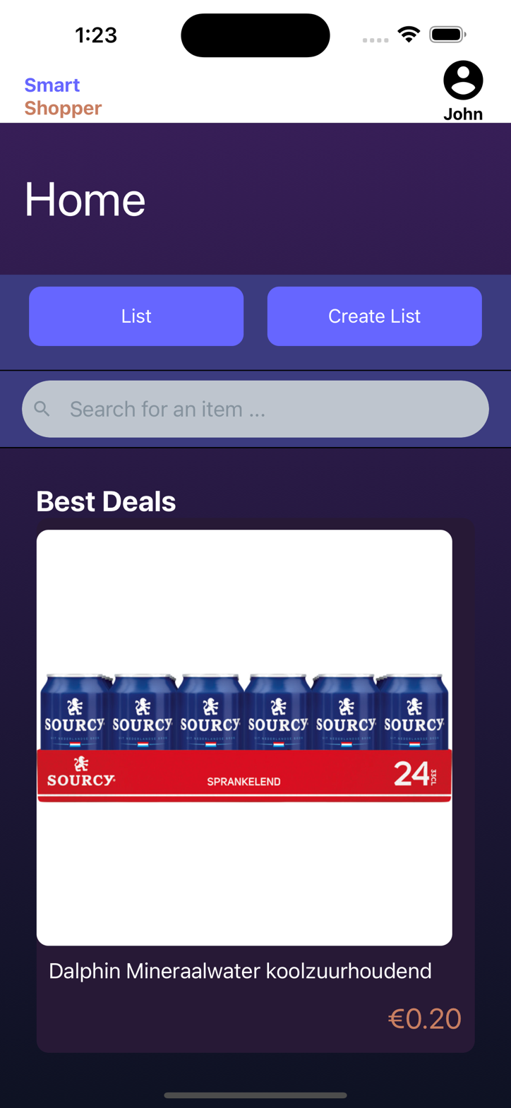

Figure 16: Home Wireframe

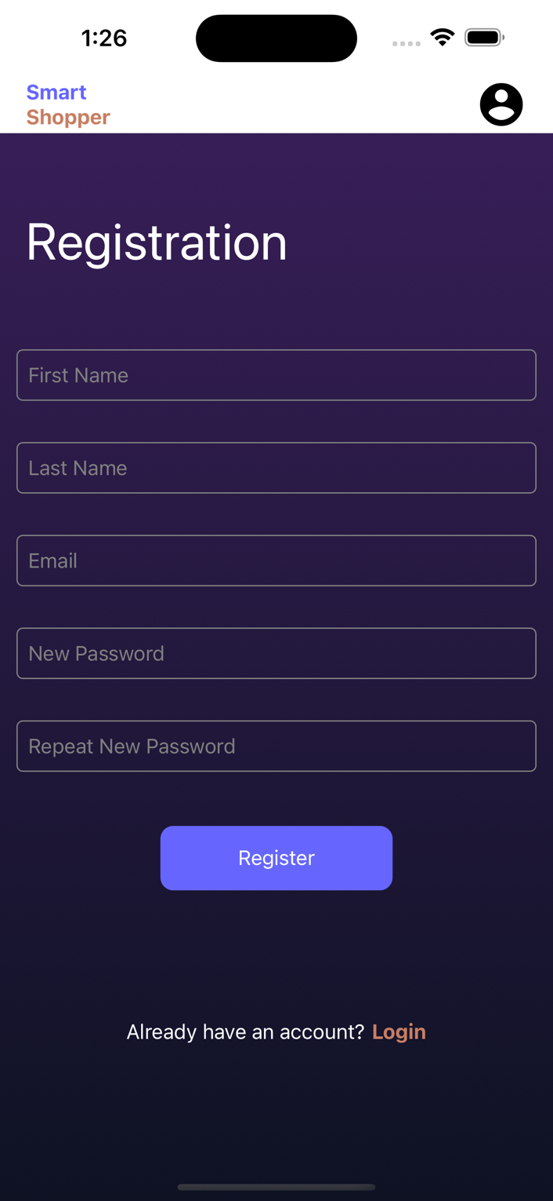

Figure 17: Register Wireframe

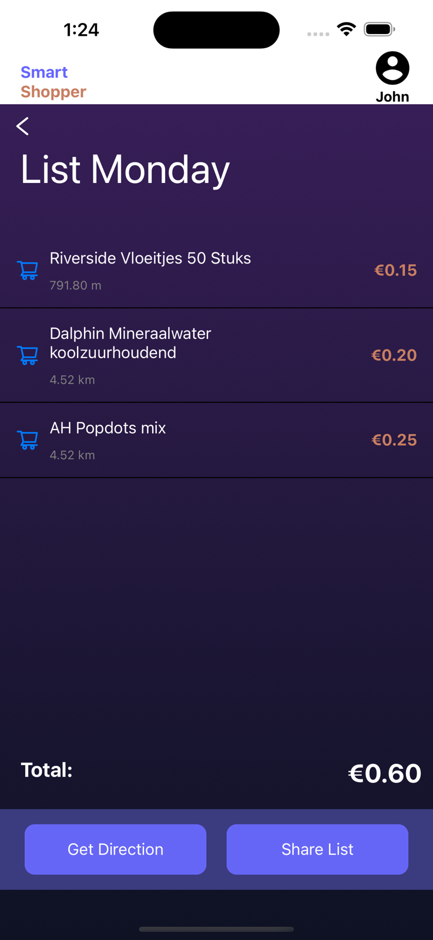

Figure 18: List Wireframe



Figure 19: All Lists Wireframe

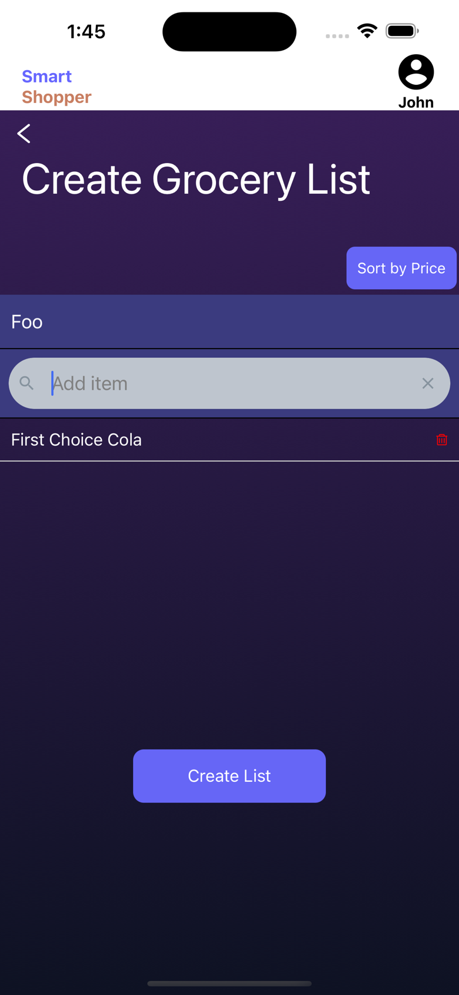

Figure 20: Create New List Wireframe

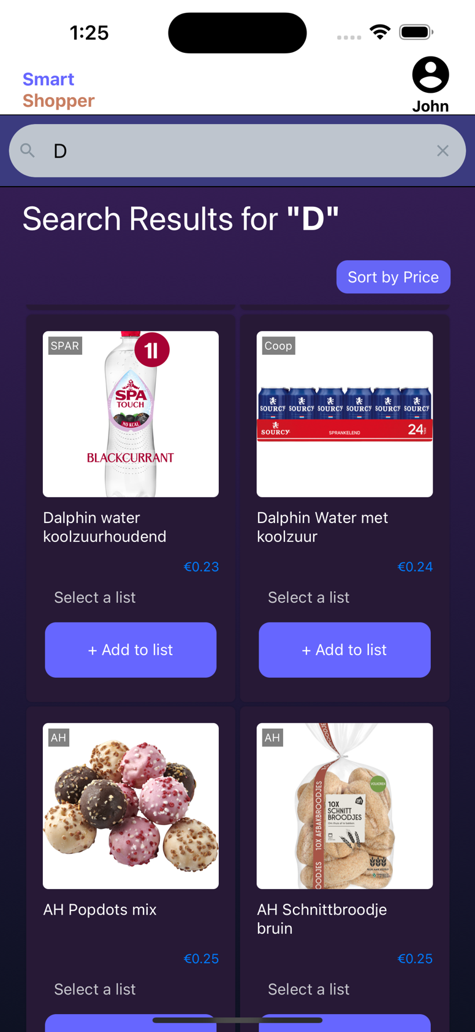

Figure 21: Supermarket Based Dropdown List

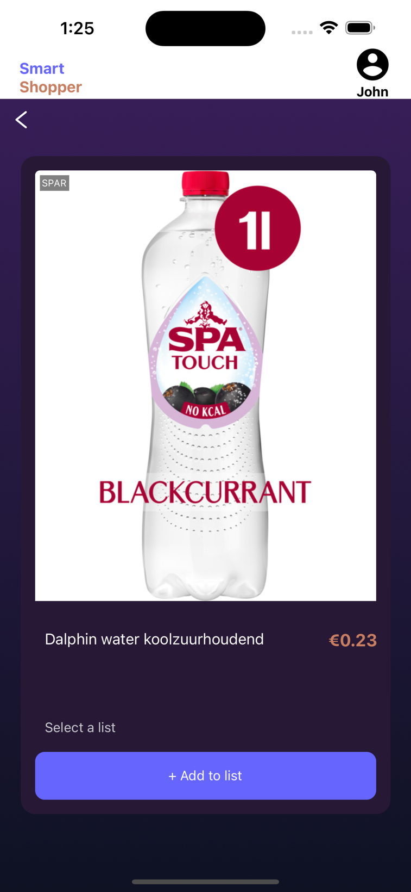

Figure 22: Item

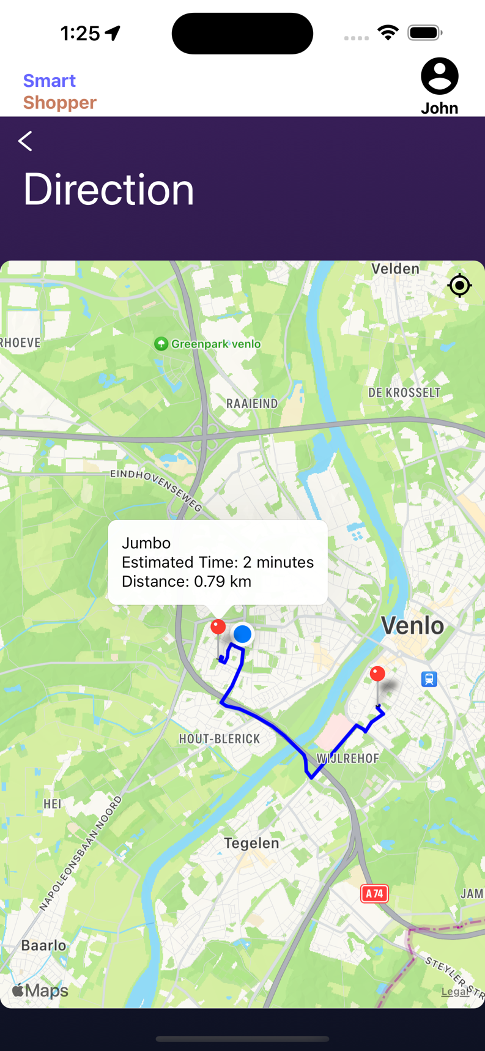

Figure 23: Stores Routing

**Reflection**

During this internship, I learned a lot about software development, and working on the Smart Shopper project was stepping into the real world of making cool software. My academic skills could now be used in a real-world situation thanks to these internship opportunities. Gathering project requirements, a crucial phase in the development process, was the main emphasis of the first few weeks of the internship. Defining the functional and non-functional needs throughout this phase highlighted the importance of good communication and teamwork with the client. This taught me how important it is to communicate well with the stakeholders you're making the application for. I got better at understanding what they wanted and figuring out any problems that I might face.

The project moved on to an exciting and difficult phase after the requirements were collected for the analysis and design phases. After visualizing the actors and their relationships with use case diagrams, I wrote thorough use case descriptions. I use diagrams to show who would use the app and how they would use it. It's like planning the blueprint of a house, but with technology, making detailed descriptions of how each part of the app would work was a bit like planning a floor. I learned that having a strong plan is super important, like having a sketch that shows exactly what is what.

One big challenge was deciding how to get information from different grocery stores. It was like choosing the best way to skitch the map from different angles. After thinking it through, I decided to use a special tool called the Checkjebon API to get information about items, prices, and deals. It was like finding a magical key point that made the skitch the map in best way.

When it was time to put everything into action, I faced some challenges, especially in making sure our app could talk nicely with the Checkjebon API. But guess what? Teamwork saved the day! I asked my teammates for help, and I also checked with the people I was making the app for. Working together made everything smoother.

Through all this, I got better at communicating with people, managing my time, and using resources wisely. It was like becoming an architect in the world of making cool apps. Looking back, this whole internship experience made me way better at making software. Being at CGI, surrounded by smart experts, was like being in a professional engineer in the architect world. Now, I'm all set and excited to use what I've learned in my next journeys of building awesome things with technology.

1. (*Company overview*. n.d.)
2. 1 = small chance or slight impact, 5 = big chance or considerable impact
3. (Cardello, 2023)
4. (Triare Ukraine, 2023):
5. (Cooper, 2023)
6. (Wordsmith, 2023)
7. (Team et al., 2023)
8. (Owens, Michael, 2006)
9. (Chacon, Scott; Straub, Ben, 2014)